Que.Creating sample tables and inserting values.create the following tables with the given structures and insert sample data as specified:-

Roll no:-84016

page1
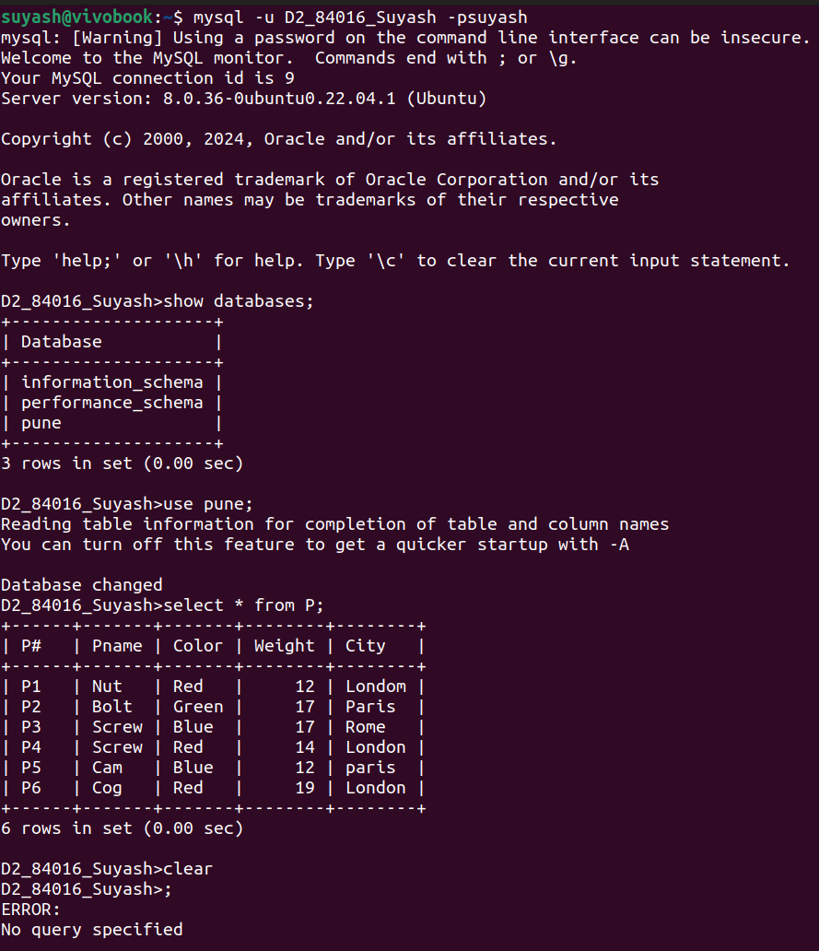
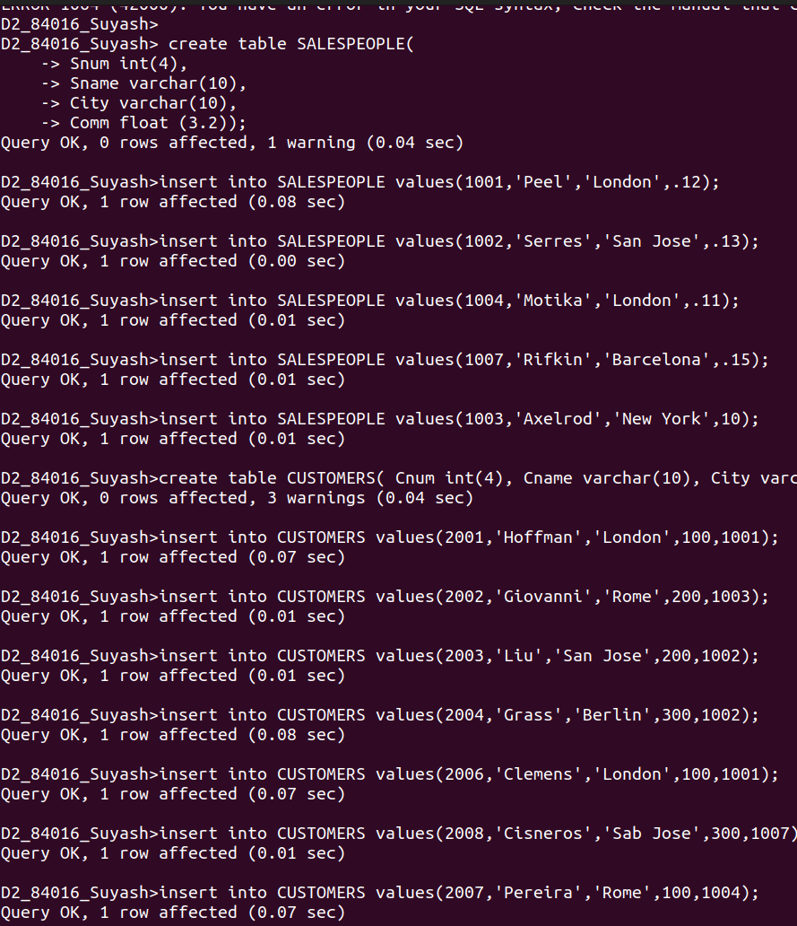
page 2
page 3

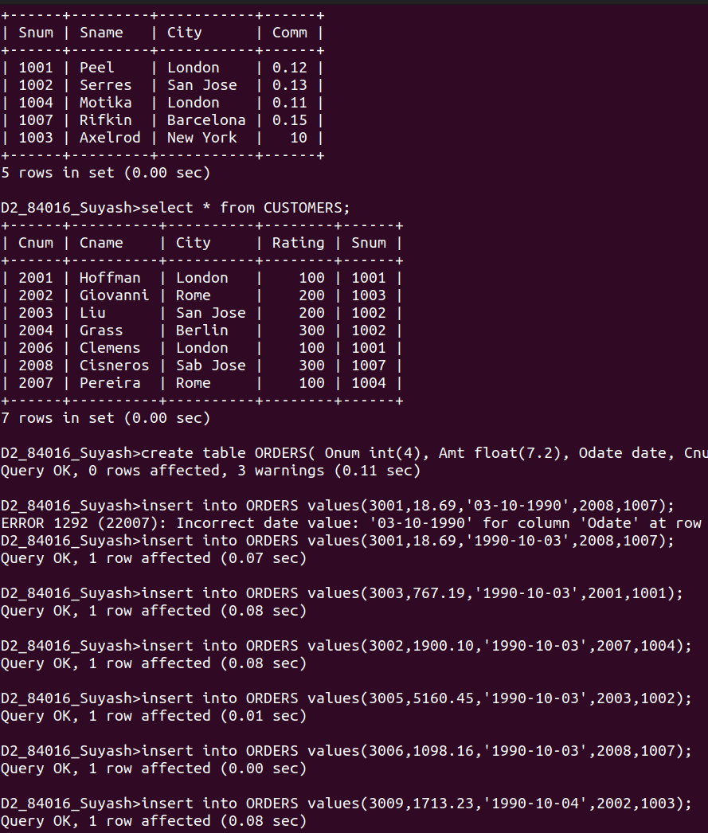

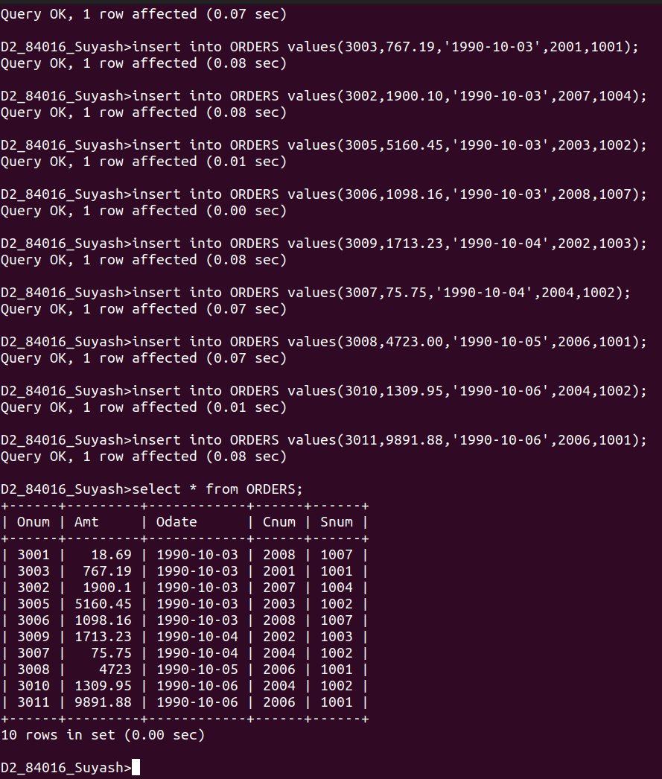
page 4

